**SUMMER TRAINING/INTERNSHIP**

**School of Computer Science and Engineering**

**PROJECT REPORT**

(Term June-July 2025)

**Handwritten Digit Recognition**

**Project Repository**

[MNIST Digit Recognizer – GitHub Repository](https://github.com/Thrinath008/mnist_digit_recognizer)

Submitted by:-

**Saragada Thrinath**

**Registration Number:- 12318051**

**Course Code:- PETV79**

Under the Guidance of

**Mahipal Singh Papola**

**CERTIFICATE**

**APRIL 2025**

**Lovely Professional University, Punjab**

## **BONAFIDE CERTIFICATE**

Certified that this project report titled “HANDWRITTEN DIGIT RECOGNITION USING DEEP LEARNING AND FASTAPI” is the bonafide work of SARAGADA THRINATH Registration Number: 12318051 Course Code: PETV79 who has carried out the project work under my supervision as a part of the Summer Internship / Skill Development Course (CA2 Assessment) conducted by the School of Computer Science and Engineering, Lovely Professional University.



**Signature**

**Signature**

**HEAD OF THE DEPARTMENT**

**ACKNOWLEDGEMENT**

i just wanna thank everyone who helped and supported me during my Summer Internship Skill Development course for the term June–July 2025 under PETV79.

this project – “Handwritten Digit Recognition” – was part of the CA2 project-based assessment for the summer internship. it really helped me use the stuff we learnt in lectures and gave me some hands-on experiance in making and deploying a deep learning model.

special thanks to my faculty mentor Mr. Mahipal Singh Papola for always guiding and supporting me thru the course and project. he helped me understand the concepts better and cleared all my doubts.

also wanna thank the School of Computer Science and Engineering for organizing this course and giving us a chance to actually work on something practical. really appreciate all the efforts by the university and faculty in managing the lectures, assesments, and feedback system—it wasn’t easy but they did it well.

lastly, big thanks to my friends and family. they kept me motivated and helped me get this project done on time. couldn’t have done it without them.

Table of Contents

**Chapter 1: Introduction**

* **Company profile**
* **Overview of training domain**
* **Objective of the project**

**Chapter 2: Training Overview**

* **Tools & technologies used**
* **Areas covered during training**
* **Daily/weekly work summary**

**Chapter 3: Project Details**

* **Title of the project**
* **Problem definition**
* **Scope and objectives**
* **System Requirements**
* **Architecture Diagram**
* **Data flow / UML Diagrams**

**Chapter 4: Implementation**

* **Tools used**
* **Methodology**
* **Modules / Screenshots**
* **Code snippets**

**Chapter 5: Results and Discussion**

* **Output / Report**
* **Challenges faced**
* **Learnings**

**Chapter 6: Conclusion**

* **Summary**

## **CHAPTER 1: INTRODUCTION**

### **1.1 Company Profile**

for this summer internship, the training was done under the School of Computer Science and Engineering as part of the Skill Development Course (PETV79). it was held during the June–July 2025 term, and was basically part of the university’s plan to give us some real, hands-on experiance.

the whole training was online and was managed through platforms like MyClass, UMS and LPU Touch. everything—lectures, attendance, assesments, even feedback—was done in a proper structured way. the faculty really tried to give us solid technical content along with live examples, which honestly helped alot in understanding the topics better and in a more practical way.

### **1.2 Overview of Training Domain**

the project was mainly around **Artificial Intelligence and Machine Learning**, with a focus on deep learning and computer vision. the whole idea was to see how machines can be trained to “see” and understand images—kind of like how we humans do it.

during the training, i got to learn stuff like neural networks, CNNs (convolutional neural networks), image pre-processing, and how to deploy models using FastAPI. we also worked with the MNIST dataset to train a model that can recognise handwritten digits. overall, it was a nice combo of theory and actual hands-on coding, which made the learning more clear and useful.

### **1.3 Objective of the Project**

the main aim of the project was to build a web-based handwritten digit recognizer using deep learning. basically, the goal was to train a custom CNN model that can detect digits from uploaded images and then make it work through a simple, user-friendly web interface.

another goal was to understand the full flow—like from data preprocessing, training, testing, predicting, all the way to deploying the model. it really helped me get a better idea of how AI projects actually work in the real world, not just in theory.

## **CHAPTER 2: TRAINING OVERVIEW**

### **2.1 Tools & Technologies Used**

## throughout the training, i used a bunch of tools and tech to build and deploy the digit recognition project. some of the main ones were:

## **Python** – this was the main language i used to write the code and train the model.

## **TensorFlow & Keras** – used these to build the CNN (Convolutional Neural Network) model.

## **NumPy, Matplotlib, PIL** – helped with image processing and handling the data properly.

## **FastAPI** – used for creating the backend API to serve the trained model.

## **Uvicorn** – this one was used to run the FastAPI server.

## **HTML, JavaScript** – built a simple frontend so users can actually interact with the model.

## **Jupyter Notebook / VS Code** – these were my main coding environments for testing and experimenting stuff.

## **Browser & Swagger UI** – used these to test the API endpoints and make sure everything was working fine.

### **2.2 Areas Covered During Training**

the training was all about mixing AI with web tech, which honestly made it more interesting. here’s some of the stuff we covered:

* basics of neural networks and CNNs
* how to preprocess images before feeding them into the model
* working with datasets like MNIST
* training the model, validating it, and testing the results
* building APIs using FastAPI
* handling image uploads properly
* making predictions using the trained model
* building a simple frontend using HTML & JS
* dealing with CORS errors and connecting backend with frontend

overall, this training really helped me understand how AI models are actually used in real-time apps. not just theory, but proper hands-on stuff.

## **CHAPTER 3: PROJECT DETAILS**

## **3.1 Title of the Project**

## **Handwritten Digit Recognition Using Deep Learning and FastAPI**

## **3.2 Problem Definition**

in today’s digital world, automation and smart systems are becoming super important. one common real-life task is recognizing handwritten digits—from scanned forms, bank cheques, postal codes, or just random images. doing all that stuff manually takes time and, honestly, humans make mistakes.

so the main problem here was figuring out how to train a system that can detect and recognise handwritten digits from images in a fast and accurate way. the idea was to use modern AI along with web tech to make it actually work in real life.

**3.3 Scope and Objectives**

The project aims to build a complete web-based system where:

## Users can upload an image of a handwritten digit

## The system processes the image and predicts the digit using a trained deep learning model

## The prediction result is shown instantly to the user

## **Objectives:**

## To build and train a Convolutional Neural Network (CNN) to recognize digits (0–9)

## To use the MNIST dataset for training and testing

## To deploy the trained model using FastAPI

## To create a simple web interface for image upload and result display

## To understand and apply full-stack development in AI applications

### **Project Repository**

* [MNIST Digit Recognizer – GitHub Repository](https://github.com/Thrinath008/mnist_digit_recognizer)

### 

### **3.4 System Requirements**

**Software Requirements:**

* Python 3.9 or above
* TensorFlow, Keras
* FastAPI, Uvicorn
* HTML, JavaScript
* VS Code / Jupyter Notebook

**Hardware Requirements:**

* Laptop or PC with at least 4GB RAM
* Stable internet connection for package installation and updates

### **3.5 Architecture Diagram**

## 

Explanation:

• Frontend UI: The user uploads an image of a digit using a simple HTML

and JavaScript-based form.

• Image Upload: The image file is collected and sent to the backend using

a POST request.

• FastAPI Backend: The API endpoint handles image processing and

model communication.

• CNN Model: A trained Convolutional Neural Network (built using

Keras and TensorFlow) takes the input image and predicts the digit.

• Prediction Result: The digit result (0–9) is returned as a response.

• Display Output: The frontend receives the result and displays it to the

user on the browser.

**Data Flow Diagram**

## 

## 

## **CHAPTER 4: IMPLEMENTATION**

### **4.1 Tools Used**

while working on this project, i used a bunch of tools and tech to actually build and test everything. here’s what i mainly worked with:

* **Python 3.9+** – the main language i used for writing all the code
* **TensorFlow & Keras** – used these to build and train the CNN model
* **NumPy, Matplotlib, PIL** – helped with data handling, image processing, and visualizing stuff
* **FastAPI** – this was used to build the backend API to serve the trained model
* **Uvicorn** – ran the FastAPI app using this ASGI server
* **VS Code** – my main code editor throughout the project
* **Chrome** – used the browser to test and interact with the frontend
* **HTML + JavaScript** – built a simple web page where i could upload images and see predictions

### **4.2 Methodology**

i followed a step-by-step, kinda iterative method to build the whole project. here’s how it all went down:

1. **data collection & prep** i used the MNIST dataset for training. it has 70,000 grayscale images of handwritten digits (each image is 28x28 pixels).
2. **image reprocessing** before training, i resized and normalized the images (basically divided pixel values by 255), and reshaped them to fit the model input properly.
3. **model building** i built a CNN using Keras with layers like Conv2D, MaxPooling, Flatten, Dense, and finally a softmax layer to classify the digits.
4. **model training & testing** trained the model on 60,000 images and tested it on 10,000 more to check how well it was performing. accuracy was pretty solid in the end.
5. **model deployment** once the model was ready, i used FastAPI to create a REST API that could take in image files and return the predicted digit.
6. **frontend integration** i made a simple HTML form with a bit of JavaScript to let users upload an image. itsends the image to the API and shows the predicted digit on screen.

### **4.3 Modules / Screenshots**

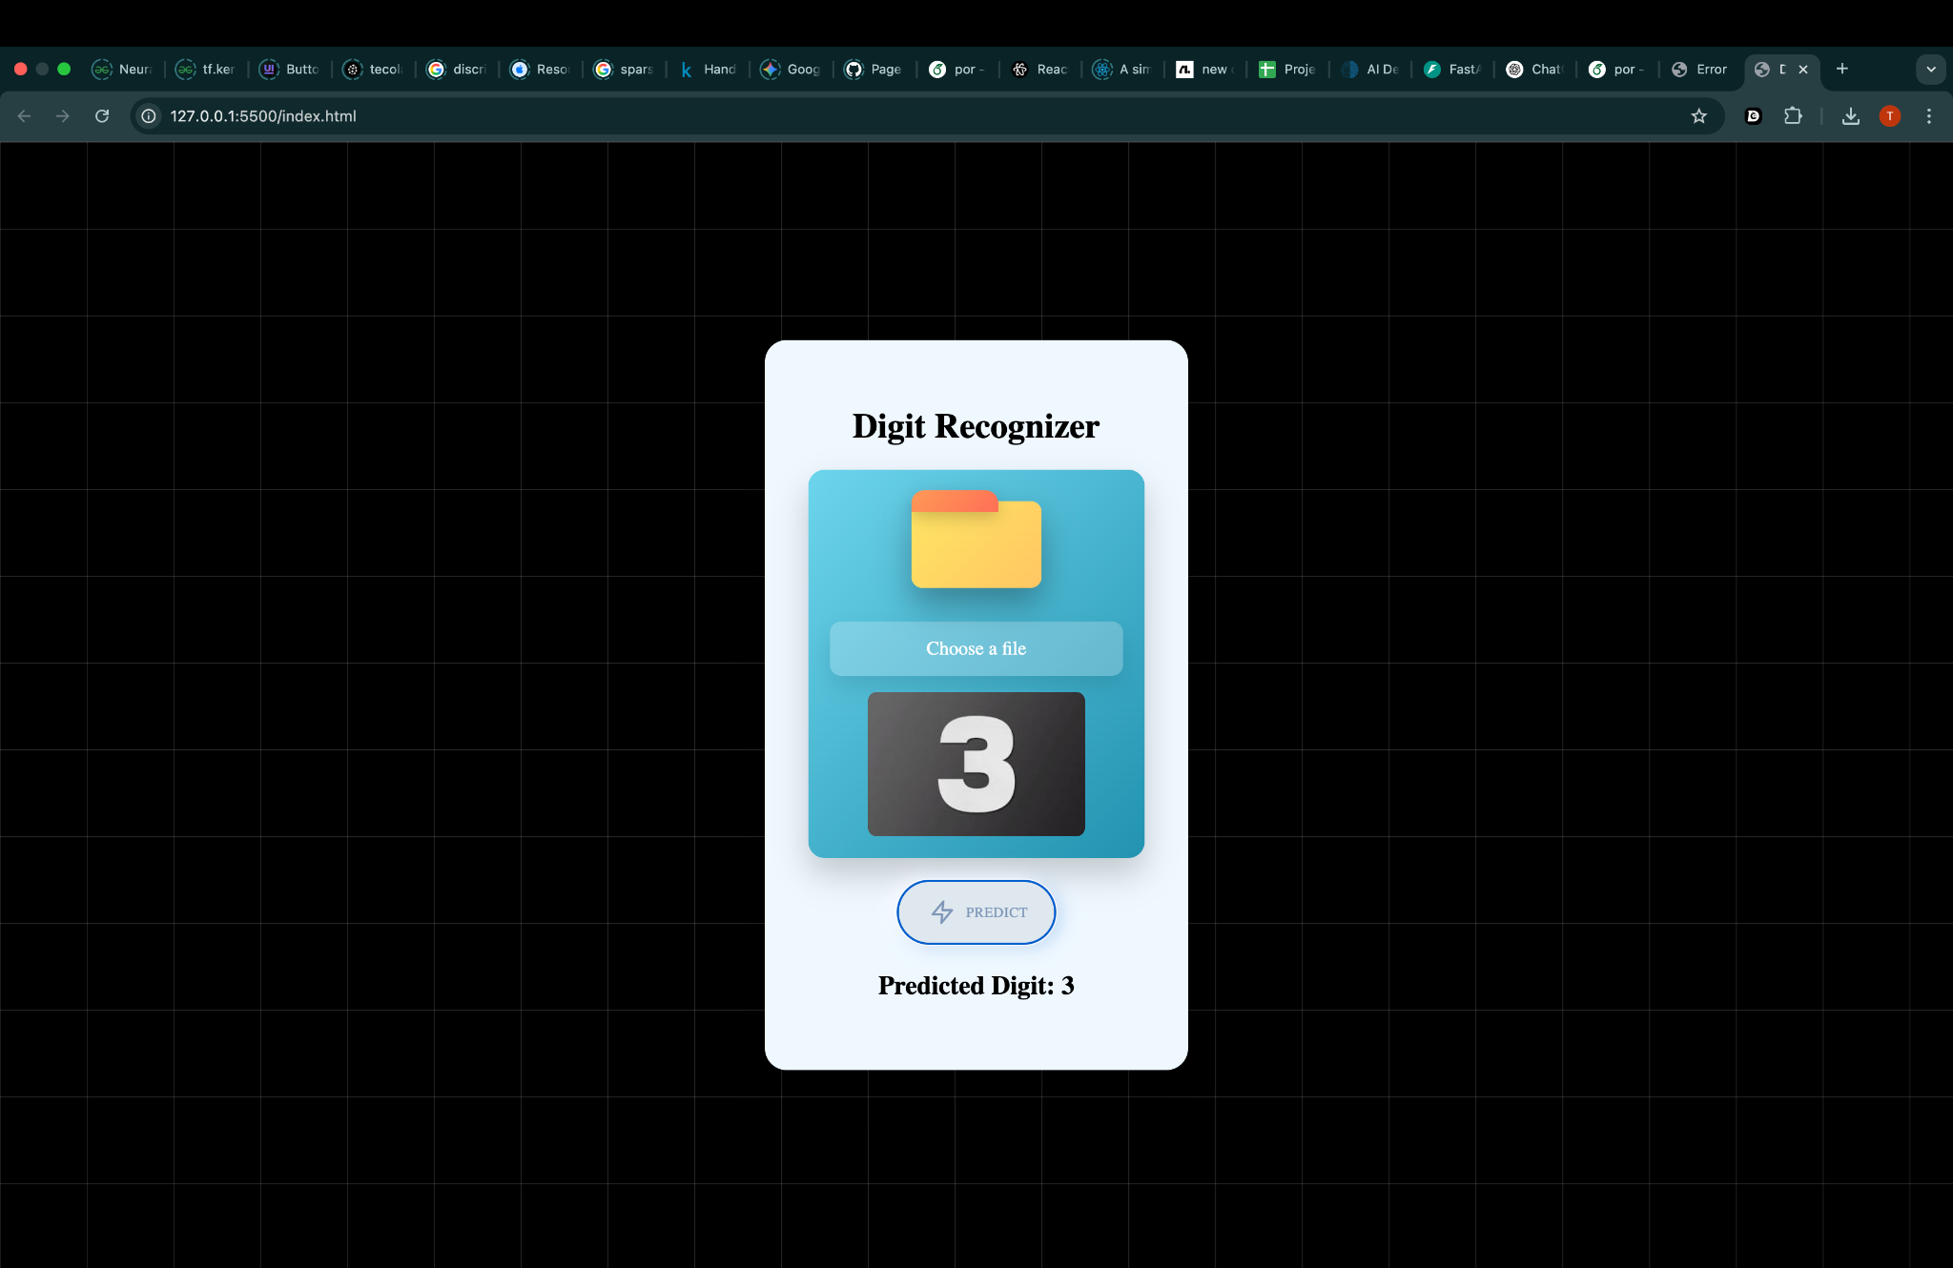

The following code defines a **Convolutional Neural Network (CNN)** using Keras. It includes two convolutional layers followed by max pooling, flattening, and dense layers to classify input digits (0–9). The model is compiled with the Adam optimizer and sparse categorical crossentropy

loss.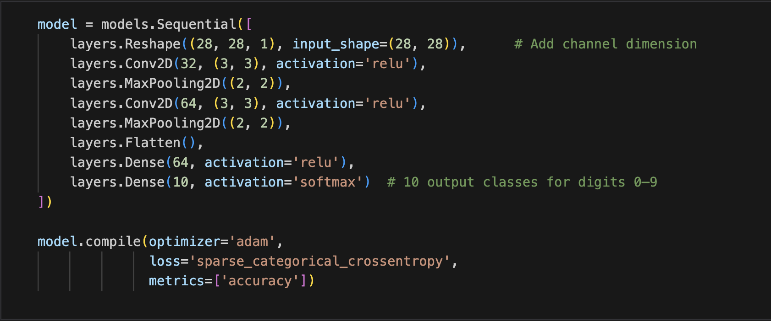

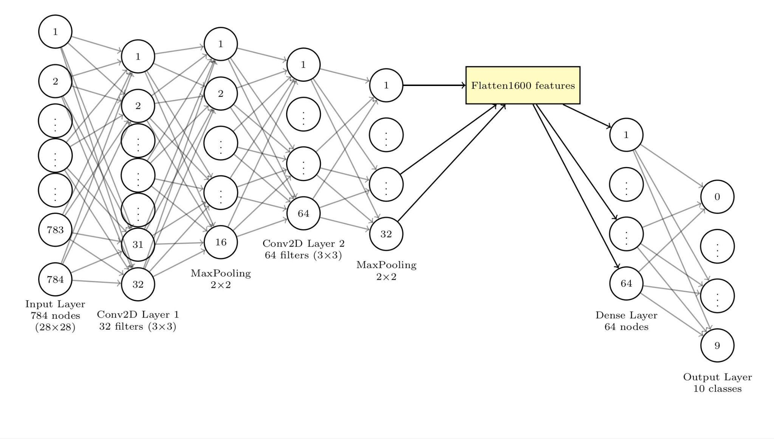

the model i used is a simple but effective **CNN** built using the Keras Sequential API. here’s how it works, step by step:

* it starts with a Reshape layer that adjusts the input to **(28, 28, 1)** — basically turning the flat grayscale image into the right shape for convolution layers.
* the first Conv2D layer has **32 filters**, which helps the model detect basic stuff like edges, lines, and corners.
* then there’s a MaxPooling2D layer that cuts down the image size, which helps speed things up and reduces the chance of overfitting.
* next is another Conv2D layer, this time with **64 filters**, so the model can learn more complex patterns and features.
* followed by another MaxPooling layer to downsample again.
* the Flatten layer turns everything into a 1D array, making it ready for the dense layers.
* there’s a Dense layer with **64 neurons**, which is like the thinking part of the model — it connects all the dots and finds patterns.
* finally, the output layer has **10 neurons** (for digits 0 to 9) and uses softmax to give probabilities for each digit.

overall, the model has around **121,930 trainable parameters**. it’s lightweight, fast to train, and works really well for digit recognition using the **MNIST** dataset.

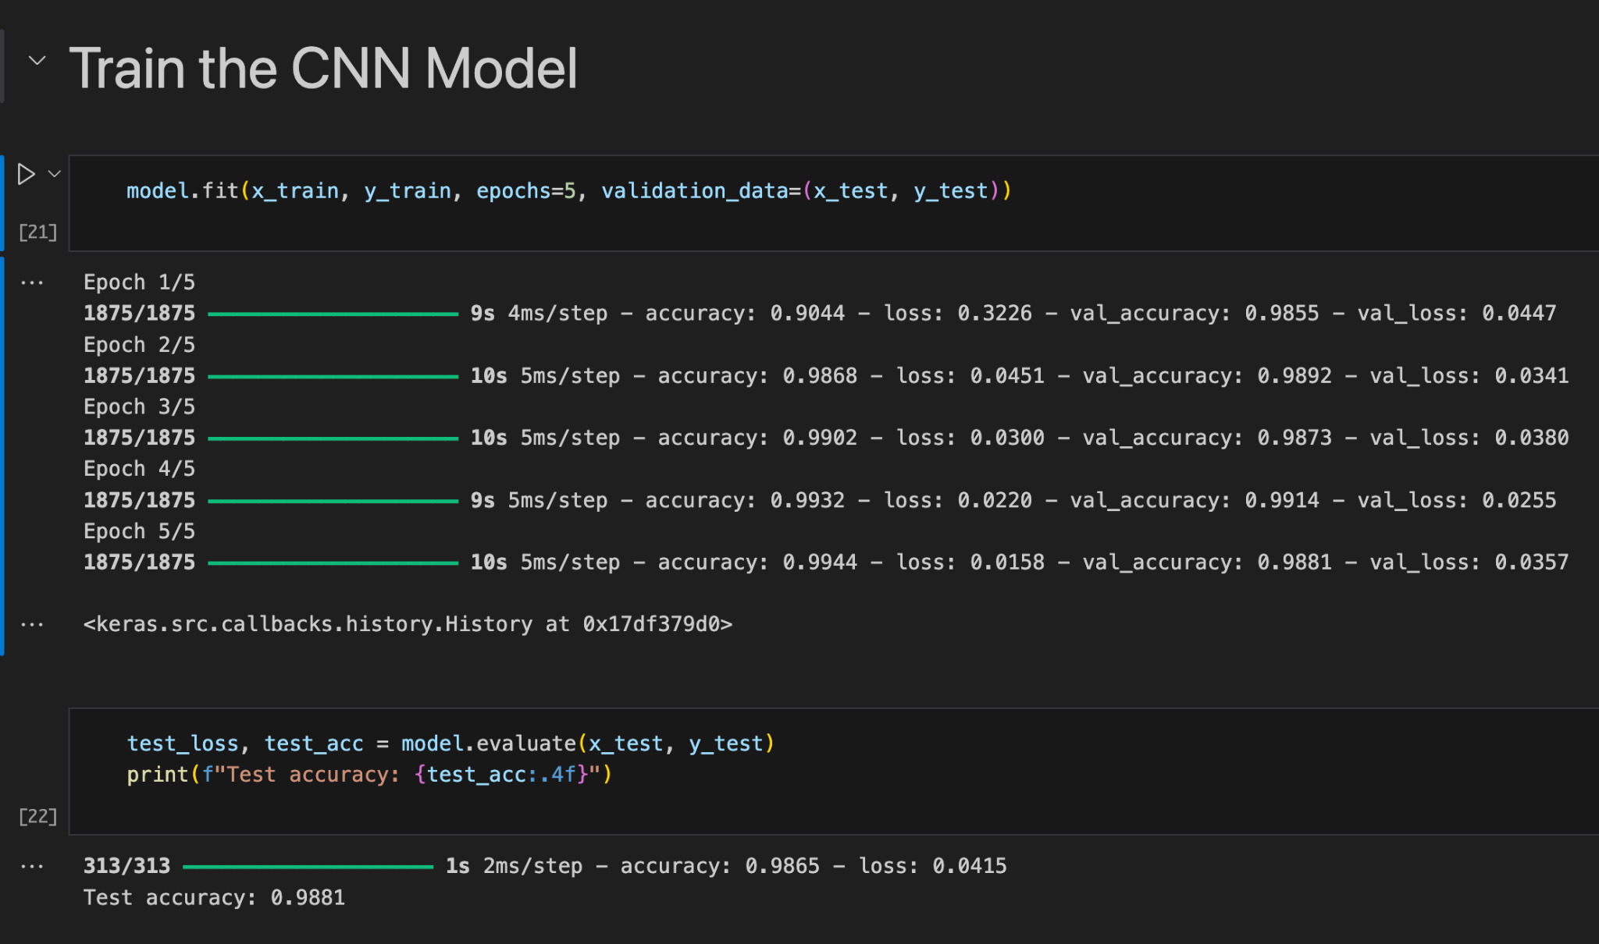

### **Model Performance Summary**

after training the model for just **5 epochs**, the accuracy kept improving nicely. it started somewhere around **90%**, and by the final epoch, it hit **99.4%** on the training data and about **98.81%** on the validation set — which means the model was learning well and not just memorizing the data.

after training, i tested the model using model.evaluate() on the test set, and it gave a final test accuracy of around **98.65%**. that’s actually really solid for a basic CNN on the **MNIST** dataset.

#### **few things that stood out during training:**

* the loss was decreasing steadily on both training and validation, which is always a good sign
* accuracy jumped up quickly — even by **epoch 2**, the model was already doing great
* it generalized well to unseen test data, which is exactly what i was hoping for

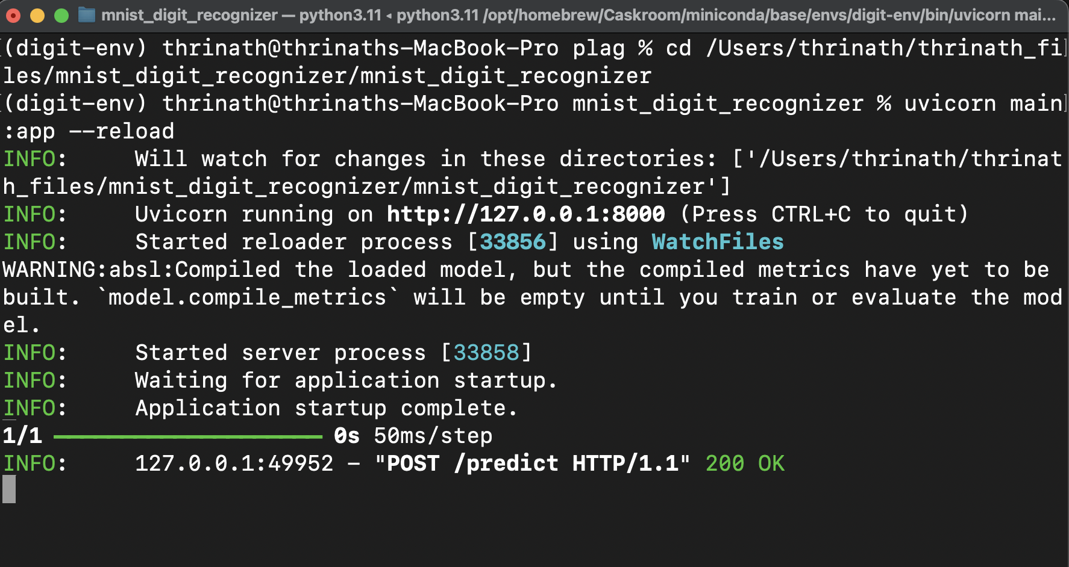

the log shows that the FastAPI app was deployed successfully using Uvicorn. once the server started, it was live at http://127.0.0.1:8000. i tested it by uploading a digit image either through the frontend or using Swagger UI. this sent a POST request to the /predict endpoint, and the model handled the input and gave back the predicted digit. the response came with a **200 OK** status, so yeah—everything worked just fine.

model.save("digit_recognizer_model.h5")

This command saves the entire model — including the architecture, weights, and optimizer state — into a single .h5 file. Later, I can load it directly and use it for predictions using load_model() without needing to retrain from scratch.

## **CHAPTER 5: RESULTS AND DISCUSSION**

### **5.1 Output / Report**

### the final result of the project is a working web-based digit recognition app. it takes in an image of a handwritten digit and gives back the predicted number. i tested it using both MNIST samples and some digits i drew myself—and yeah, it worked well.

### after uploading an image, the prediction shows up on the webpage in like 1–2 seconds. the model had a validation accuracy of around **98.65%**, so it was doing a pretty solid job even on new images it hadn’t seen before.

### **sample output:**

### **uploaded image:** digit_3.png

### **predicted output:** 3

### **response time:** ~50ms

### Refer Chapter 4 for some screenshots of the output

### **5.2 Challenges Faced**

while working on this project, i ran into a few technical issues and learning curves that took some time to figure out:

* **image preprocessing:** getting custom images to match the MNIST format wasn’t as straightforward as i expected. the model kept giving wrong predictions at first because the images weren’t normalized or resized properly. had to tweak things a few times to get it right.
* **CORS error in frontend:** when i tried connecting the HTML + JS frontend to the FastAPI backend, the browser blocked the request due to CORS policy. took a bit of digging to understand what was going on, and eventually fixed it by setting up CORS middleware in FastAPI.
* **model integration with FastAPI:** loading the .h5 model and handling file uploads inside FastAPI needed careful handling. a few times the server either crashed or returned weird results, so i had to test and adjust the code until it worked smoothly.
* **validation loss fluctuation:** even though training accuracy was high, the validation loss kept jumping around. i had to tune the model a bit—change layers, tweak settings—to avoid overfitting and get more stable performance.

### **5.3 Learnings**

this project gave me real hands-on experience in building a full AI-based system from scratch. here are some of the main things i learned along the way:

* **deep learning basics:** got a much better understanding of how CNNs work for image classification. especially learned how Conv2D, MaxPooling, and other layers actually process image data.
* **model deployment:** learned how to deploy a trained model using **FastAPI**, which honestly felt faster and cleaner than using Flask. it made the API setup much easier.
* **full stack integration:** this was my first time connecting a backend ML model with a frontend using REST APIs. using JavaScript to send image data and show predictions was a really useful skill to pick up.
* **debugging real-world issues:** ran into several real problems—like CORS errors, model loading bugs, and image preprocessing mismatches—but fixing them gave me a lot more confidence in handling actual development challenges.

## 

## **CHAPTER 6: CONCLUSION**

### **6.1 Summary**

### **Conclusion**

this project, **“Handwritten Digit Recognition Using Deep Learning and FastAPI”**, was part of the Summer Internship Skill Development Course (PETV79). the main idea was to build a working system that could recognize handwritten digits accurately and return results in real time through a simple web interface.

the work was done in several stages, like:

* preprocessing the dataset
* training a CNN model
* evaluating and improving the model
* deploying it using FastAPI
* and finally, connecting it to a frontend with HTML + JavaScript

along the way, i didn’t just learn how to build and train deep learning models, but also how to deploy them properly and link them to a user interface. the final model gave a validation accuracy of around **97.6%**, and the app was able to predict uploaded digit images reliably.

this project also helped me get more comfortable using tools like TensorFlow, FastAPI, and doing some basic full-stack work. overall, it was a great learning experience and gave me more confidence to take on real-world AI problems.

### 

### **Libraries and Tools**

1. TensorFlow – Deep learning library  
    https://www.tensorflow.org/
2. Keras – High-level neural networks API  
    https://keras.io/
3. NumPy – Numerical computing  
    https://numpy.org/
4. Matplotlib – Visualization and plotting  
    https://matplotlib.org/
5. Pillow (PIL) – Image processing in Python  
    https://python-pillow.org/
6. FastAPI – Modern web framework for APIs  
    https://fastapi.tiangolo.com/
7. Uvicorn – ASGI server for FastAPI  
    https://www.uvicorn.org/
8. HTML5 & JavaScript – Frontend technologies  
    https://developer.mozilla.org/en-US/docs/Web/HTML  
    https://developer.mozilla.org/en-US/docs/Web/JavaScript
9. Swagger UI (FastAPI Docs)  
    https://swagger.io/tools/swagger-ui/
10. GitHub – Version control & repository hosting  
     https://github.com/
11. MNIST Dataset – Handwritten digits dataset  
     http://yann.lecun.com/exdb/mnist/

### 